Brian Dones

Professor Cannistra

Internetworking



Lab Journal 00

**Journal Description:** In this lab, we will be utilizing Cisco Packet Tracer to create a topology where we are connecting a PC to PC using a crossover cable. Being that the two PCs are similar devices, we will need to use the crossover cable as opposed to a straight-through cable because crossover cables allow connections and communication between the same devices (E.g. Switch to a Switch). If this topology works, we should have two PCs connected via their Fast Ethernet Network Interface Cards that are able to successful ping each other.

**Topology:** Below is a picture of the topology we are setting up. You can also view this in the **LabJournal00.pkt** file.

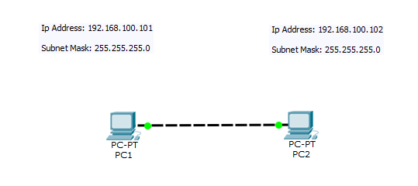

**Table of Command Syntax:**

|  |  |
| --- | --- |
| Command | Description |
| Ping | Used for testing connectivity to a device |

**Verification:** To verify that we have connectivity among the PCs we will need to use the ping command in the command prompt on both PCs. Below are screenshots of the ping requests in the command prompt.

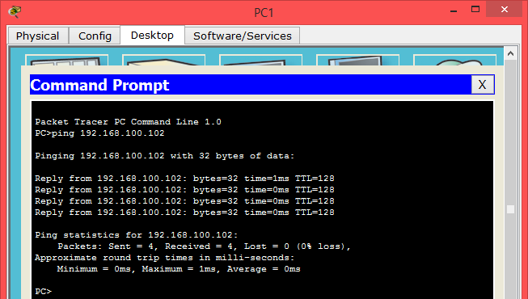

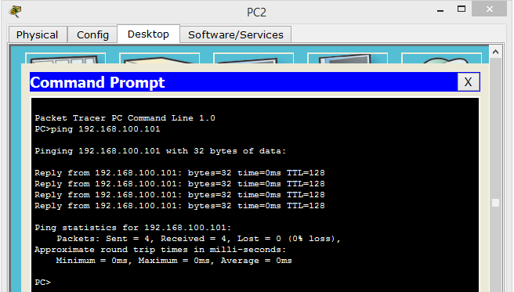

**Results and Outcomes:** This lab was fairly straight forward so there were no difficulties in creating this topology. All we had to do was assign both PCs their respective IP Address and Subnet Masks and connect both PCs using a crossover cable. After doing this, we are able to successfully ping from one PC to the other PC ensuring that we have connectivity.